# **Primitive Data-types**

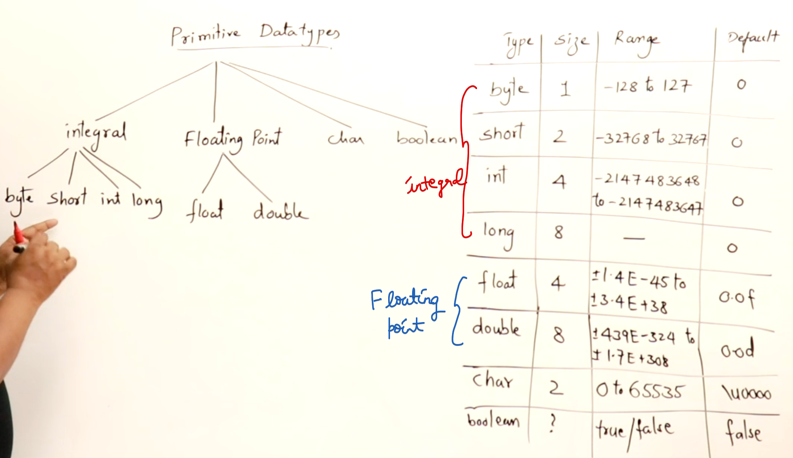

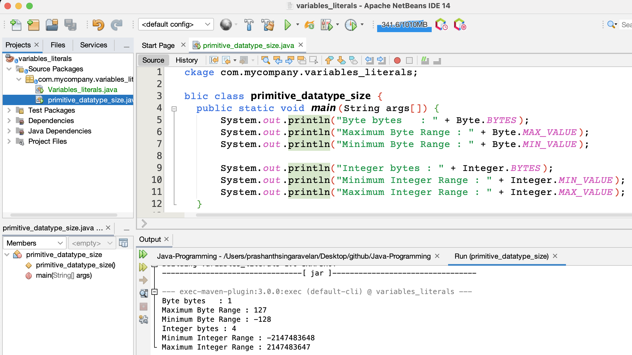

To see the packages installed in a class. The below functions are present inside Integer class

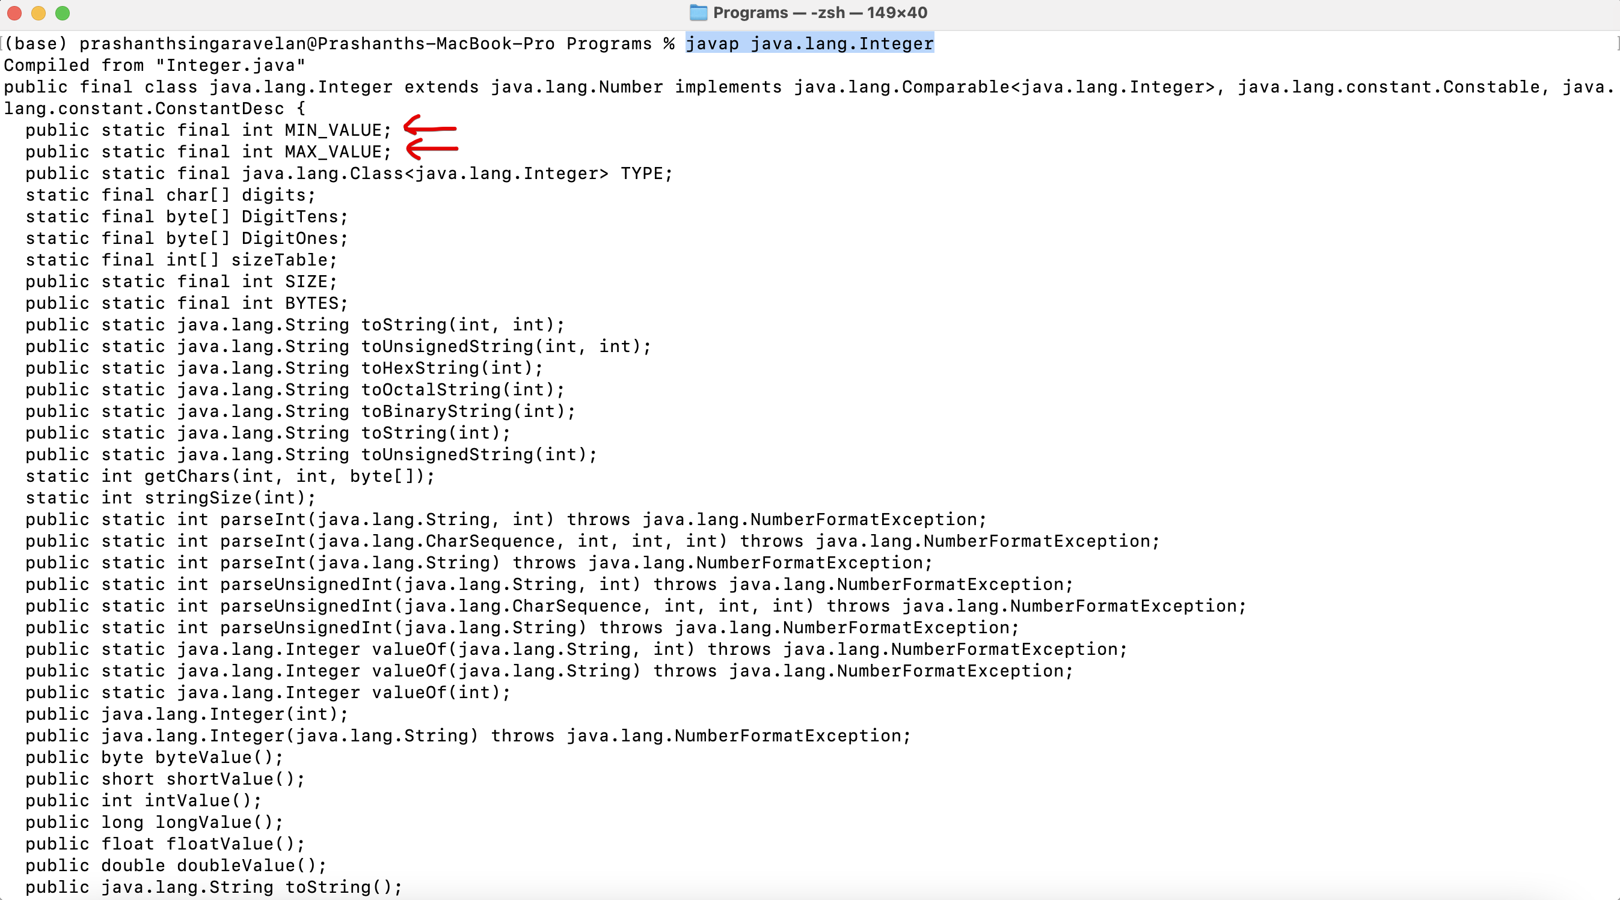

# **What are variables ??**

The memory is allocated only at the run time.

# **Variables – Naming Rules**

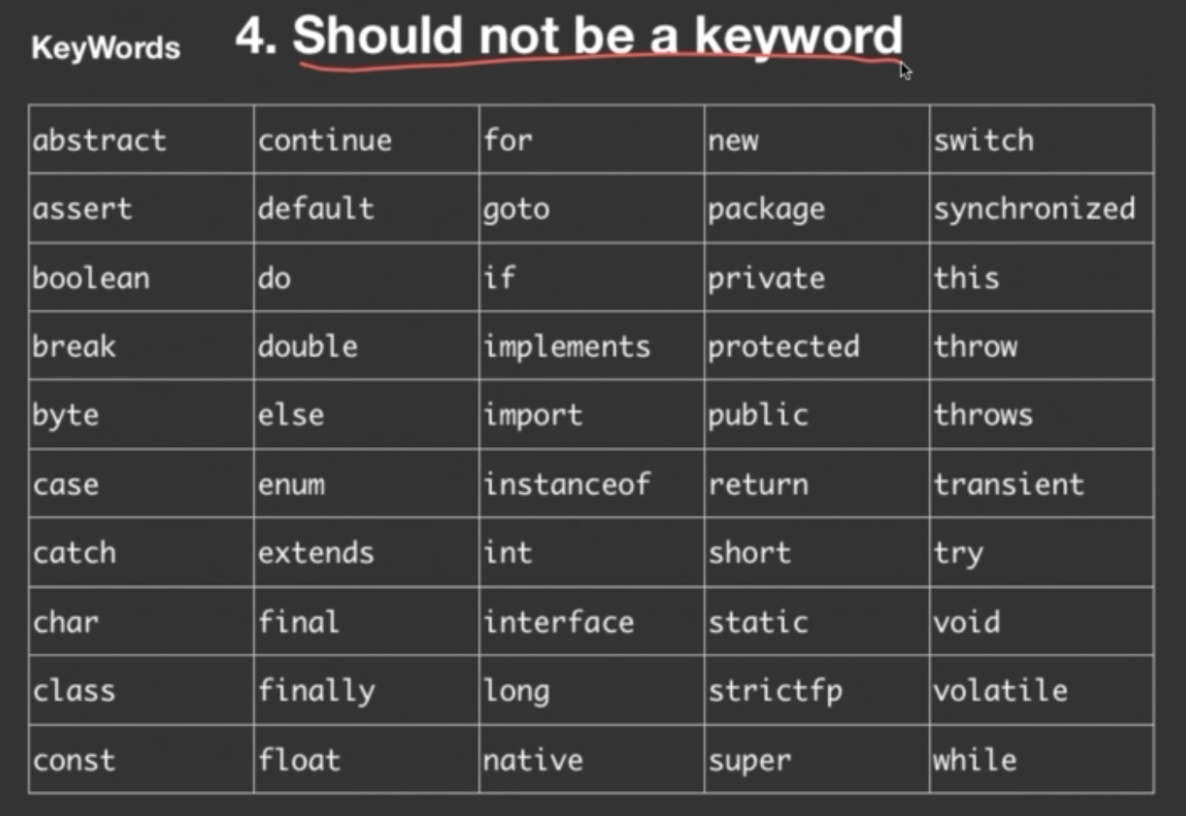

# **Literals**

Literals are the constant values that are used in the program.

Variables have their own data-type. Similarly literals also have their own data-type.

Any value without decimal point 🡪 integer literal

So 5,7 and 25 are integer literals.

Any value with decimal point 🡪 double literal

So 153.75, 3.1425 are double literals

Single quotes 🡪 character literal  
Double quotes 🡪 string literal

# **References**

<https://www.udemy.com/course/java-se-programming/>